**Angeles  City Science High School**

**Conchem 9**

Name:Paul Gerald D. Pare  Section:9 - Adenine

Activity 1: Processing at Advantage or Disadvantage Objective:Identifying the effects of food processing

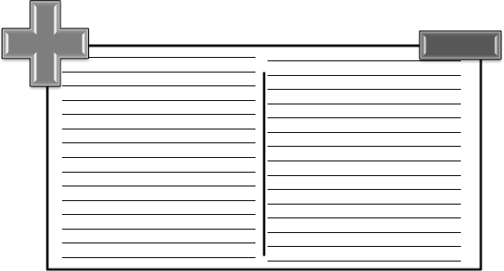**Direction:** Identify if the effects of food processing are an ADVANTAGE (+) or DISADVANTAGE (). Write it on the space provided below.

- Lessened hazards from microbial pathogens

- Lessened spoilage

- Inactivation of heat-labile, anti-nutritional substances

- Year- round availability of seasonal foods

- Availability of perishable foods

- Increased convenience

- Increased variety of foods, some with enhanced sensory properties.

- Harm to the sensory properties and nutritive value of some foods, particularly when severe methods of processing (heat sterilization, air drying) are applied to tissue foods, and - development during some kinds of processing and handling of new chemicals that must be classed as toxicologically undesirable.

Guide Questions

1. How does food processing prevent spoilage?

It prevents the growth of microbial pathogens.

1. What is the difference between processed food and raw food?

Processed foods are foods that are no longer in their natural state, because they either have been cooked or combined with other food ingredients while raw food are uncooked and unprocessed.

#### Activity 2: Added Terms

**Objective:** Define the terms used in the effects of food preservation and additives.

**Direction:** Match column A to column B. Write the letter of the answer on the lines provided.

#### COLUMN A

Food Processing 1.It is any method used to turn fresh foods into food products.

Food Storage 2. This allows food to be eaten for some time after harvest rather than solely immediately.

Perishable goods 3. These are those likely to spoil, decay or become unsafe to consume if not kept refrigerated at 40 F° (4.4 °C) or below, or frozen at 0 F° (-17.8 °C) or below.

Semi-perishable goods 4. Take longer to spoil and may or may not need immediate refrigeration. It includes onions and potatoes.

Non-perishable goods 5. Will last for a while if stored properly, though they may lose quality over time. Examples are dried beans, canned soups, and spices.

Guide Questions

1. What are the three (3) categories of food shelves’ lives?

Perishable foods, Semi-perishable foods and non-perishable foods.

1. How does food increase its food shelves’ lives?

Processed foods extend shelves’ lives of perishable food.

#### Activity 3: Food Shelf’s Lives

**Objective:** Organize the food items into three (3) categories according to food shelf’s lives. **Direction:** Complete the table by organizing the following food items according to food shelf’s lives.

* + eggs
  + Dry pasta and noodles
  + rice
  + Flour
  + Potatoes
  + Onions
  + Cured meats such as salami
  + dried spices and herbs
  + dried mushrooms,
  + Canned foods
  + Unroasted nuts
  + fresh fruits and vegetables
  + Squashes.

|  |  |  |
| --- | --- | --- |
| **Perishable Foods** | **Semi-Perishable Foods** | **Non-Perishable Foods** |
| - Fresh fruits and vegetables  - eggs | - Potatoes  - Onions  - Squashes  - Cured meats such as salami | - Dried Spices  - Dried Mushrooms  - Flour  - Canned foods  - Unroasted nuts  - Dry pasta and noodles  - Rice |

Guide Questions

1. Which set of food can be placed in the refrigerator or chilled place? Why?

Perishable foods and Semi-perishable have to be placed on chilled environment to prevent spoilage

1. Which set of food can store in the cabinet? Why?

Non-perishable foods can be stored in cabinet since it contains food additives that kills pathogen.